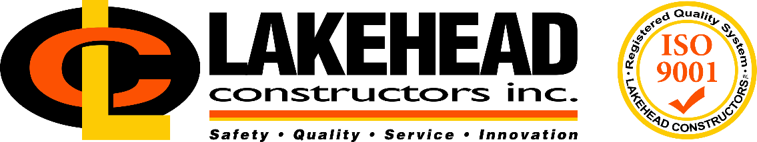

Safety Specialist

Founded in 1916, Lakehead Constructors, Inc. is a leading construction company in the Twin Ports and Iron Range, providing high-quality construction, management and building services to a wide variety of industries in the Upper Midwest region. With one of the most diverse portfolios in the area, Lakehead specializes in industrial construction, including institutional and commercial, mining and steel, oil and gas, power generation and railroad. Founded on a mission of safety, quality, service and innovation, Lakehead employs a highly skilled, flexible workforce with a passion for providing the highest quality service.

If you enjoy a fast-paced work environment that offers a wide variety of challenging work, and you have a passion for safety, quality, service and innovation, make Lakehead Constructors, Inc. your next career move. With an opportunity to be a part of a highly skilled construction team and the ability to work on a diverse portfolio of projects, Lakehead offers competitive wages and vacation, as well as an excellent benefit package including health, dental, and retirement.

Lakehead Constructors, Inc. is seeking a Safety Specialist at its Aurora, Minnesota office. The Safety Specialist will serve as a resource to supervisory and field personnel to provide guidance on hazard identification and control, safety requirements and practices, and regulatory compliance at the field level. This person will also provide guidance to Lakehead staff on company safety policies, client policies, regulatory compliance and safe work practices.

Duties and responsibilities of this position include, but are not limited to:

- Conducting audits of employee and subcontractor field compliance with federal, state, local and company safety regulations, rules and procedures
- Actively participate in the planning and implementation of safety initiatives and policies
- Perform on-site safety function for projects (may include working extended hours, night and swing shifts as necessary)
- Conduct safety training throughout the organization
- Perform job site audits of safety processes and perform compliance inspections
- Assist field personnel at various locations with hazard identification, analysis and control, and critical safety and health concerns related to safe work practices
- Evaluate job site hazards and practices and assist in the implementation of hazard control practices and programs
- Communicate hazard identification and control information and evaluate effectiveness of hazard controls
- Provide technical support and response for accident investigations company-wide
- Provide oversight for use of safety equipment.

Qualifications:

Education and / or Experience
Bachelor's degree in Environmental Health & Safety or a comparable combination of education and experience in an industrial environment will be considered.
This position reports to the Aurora, Minnesota office. Qualified candidate must have a valid driver’s license, as travel to job sites will be required.

Competencies
- Strong persuasive skills in dealing with executive management, managers and field supervisors
- Ability to organize safety concepts and materials into lesson plans and present training to managers and field labor effectively
- Strong phone communication skills
- Ability to efficiently use computer and typical business software
- Ability to learn and become proficient with LCI specific software

Pay is commensurate with education and experience. Please send resume to Lacie Jurek, Human Resources Manager, at ljurek@lakeheadconstructors.com.

Lakehead Constructors, Inc. is an Equal Opportunity Employer

